**Coursera Capstone Project**

Kevin McCarron

1. Introduction
   1. Background

Brooklyn is a borough of New York City, in the state of New York. It is the second most densely populated county in the United States with over 2.5 million residents. It has a huge GDP of $92 billion, bigger that the GDP of approximately 70% of the world’s countries. Brooklyn is home to a wide variety of ethnicities and cultures, with nearly 50% of the population having a language other than English as their first language

1.2 The Problem

I want to investigate the best place for a particular business to open up, in this case a yoga studio, based on a variety of factors, such as population’s density, property prices, competition and how affluent the particular neighbourhoods may be. While I will focus on a yoga studio example, I will try to keep my research general, so that a wide variety of businesses could follow the same data with a few simple changes.

* 1. The Interest

I believe that this information will be useful to any aspiring entrepreneur or small business owner looking to open a business or branch in Brooklyn. This information should help choose the optimum location for their business, helping them to ensure lots of potential clients, while keeping costs as low as possible.

1. Data

2.1 Foursquare API

I used Foursquare API to explore the different categories of venues in Brooklyn, as well as how common they are, and their latitude & longitude. This information will be the basis from where I will build my argument for the location to start the business, for example, if there are several yoga studios in a particular area, does this mean that it a bad place to set up as there is competition, or a good place as there are already potential clients in the area? I hope to make my argument around discussions like this.

2.2 Wikipedia

I scraped different Wikipedia pages to show the relevant population densities and incomes by neighbourhood, as well as potential property prices by neighbourhood, in order to find the optimal location for the prospective business. I will combine this information with the Foursquare information in order to make my arguments.

Methodology

I wanted to find all the venues that were available in Brooklyn so I used the New York dataset to show the different neighbourhoods & I put their exact locations into a dataframe.

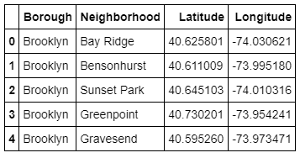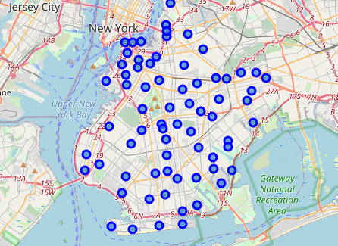

Taking the Bay Ridge neighbourhood as an example I began to analyse the different types of venues in Brooklyn

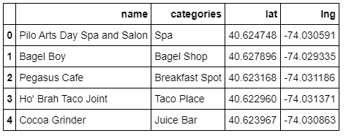

After looking at the amount of venues per neighbourhood I wanted to see how many of each particular type there were in each neighbourhood. From here on my focus changes to a yoga studio, however, the information can still be used for a different type of venue.

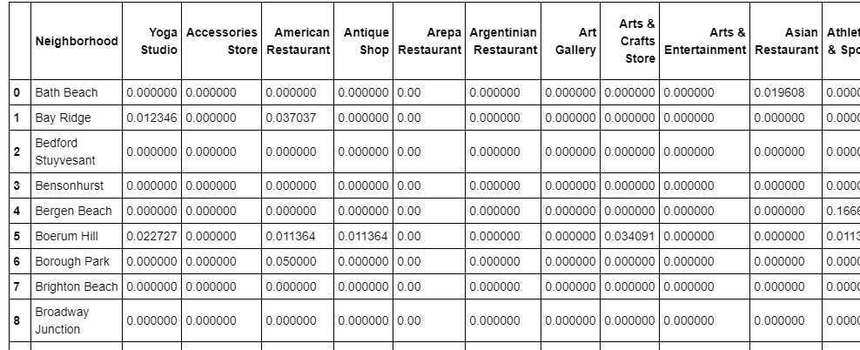

I wanted to see what the most common venues in each neighbourhood were and in particular which neighbourhoods already had at least one yoga studio

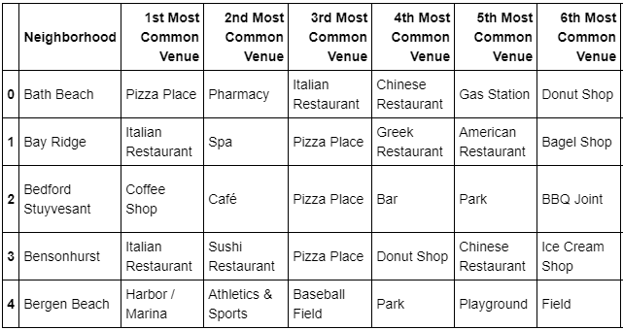

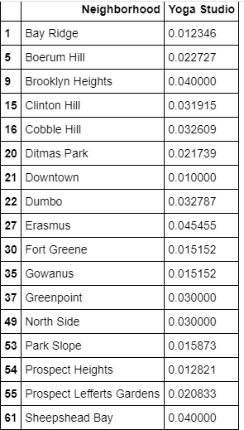

Next I wanted to see what were the most populated areas, and as a consequence, the place with the most potential clients. So I scraped the populations by neighbourhood from Wikipedia.

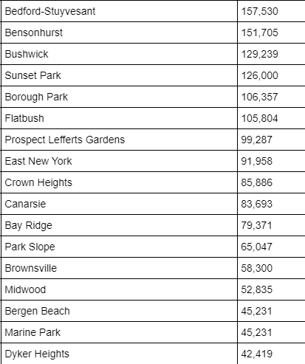

Finally I wanted to match neighbourhoods without yoga studios, with high populations to the average cost of rent in the area, again scraping the information from a different website.

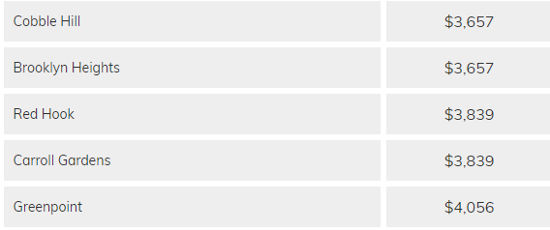

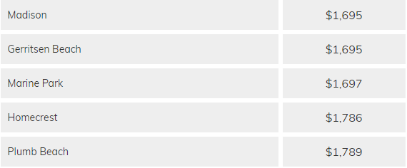

Results

There are several neighbourhoods that fit with the criteria that I have set out. Bedford-Stuyvesant the most populated neighbourhood in Brooklyn with a population of over 150,000. It doesn’t currently have a yoga studio. The average rental property in Bedford-Stuyvesant is $3,042.

Bensonhurst is the second most populated neighbourhood in Brooklyn with a population also slightly above 150,000. It doesn’t currently have a yoga studio. The average rental property in Bedford-Stuyvesant is $1,869.

Flatbrush is another highly populated area, although significantly less than the previous 2 I have mentioned with 100,000. It doesn’t currently have a yoga studio. The average rental property in Flatbrush is $2,027.

The final option I will discuss is Downtown Brooklyn. While it does already have a yoga studio, there is only 1, although the population of the neighbourhood is only approximately 7,000. The average rental property in Downtown Brooklyn is $3,657.

Discussion

The decision will come down to the owner and how they want to market their product. If they want to go for the top end of the market, set their prices high and keep their classes to a small number then they should consider Downtown Brooklyn or Bedford-Stuyvesant. However, they will need to factor in much higher running costs with the rent they will be expected to pay and other associated costs of working in an upmarket neighbourhood.

If the owner wants to have a cheaper model, where the customer pays less and participates in higher volume, lower cost classes, then I would recommend either Bensonhurst or Flatbrush. Both are relatively cheap ad both have high populations with no yoga studios currently.

Conclusion

Once the decision has been made about which model the business wants to go for then I would recommend Bedford-Stuyvesant from the higher end options and Bensonhurst from the lower end options. Neither has a yoga studio currently, while both have huge populations of over 150,000.